ASIAN PARLIAMENTARY ASSEMBLY

The Meeting of APA Standing Committee on
Budget and Planning
3 - 5 September 2019
Baghdad, Iraq

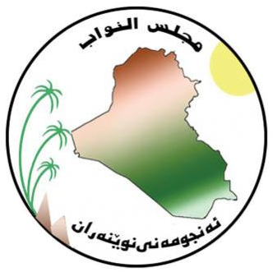
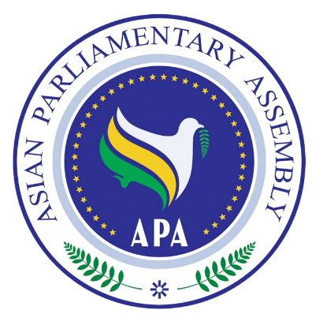
REGISTRATION FORM

REGISTRATION FORM

Please fill in one form for each participating delegate in CAPITAL letters

DELEGATE DETAILS
Country: |  | Name of Parliament:
Salutation | ( ) Mr. ( ) Ms.
First Name
Last Name
Position | ( ) Head of Delegation ( ) Member of Parliament ( ) Officer
Tel. No.
Mobile No.
Fax No.
Email Address

PASSPORT DETAILS
Passport Type |  |  | ( ) Diplomatic ( ) Official ( ) Ordinary
Passport Number: |  |  |  |  |  | Date of birth :
Date of Issue: |  |  |  | Date of Expiry: |  | Place of Issue:

TRAVEL INFORMATION
Arrival |  |  | Departure
Date | Flight Number | Time | Date | Flight Number | Time

Kindly complete this form and send it together with a scanned copy of the information page of your passport and one 2″ x 2″ digital passport-sized photo, no later than 22 August 2019. Please forward
(e-mail) the filled in the Form to the Host Secretariat with a copy to the APA Secretariat in Tehran:

CC to APA Secretariat:

Email: secretariat@asianparliament.org
Phone: (+98-21) 33517406 - 7
Fax: (+98-21) 33517408
Host Secretariat:

Email: apairaq2019@gmail.com

Contact Person: | Mr. Wameed Ali Shukr
Tel & : | 009647809295779

